**EX.NO:3 DATE:16/10/2024**

**Reg.no:220701048**

**DEPTH-FIRST SEARCH – WATER JUG PROBLEM**

**AIM**:To implement water jug problem using DFS

In the water jug problem in Artificial Intelligence, we are provided with two jugs: one having

the capacity to hold 3 gallons of water and the other has the capacity to hold 4 gallons of water.

There is no other measuring equipment available and the jugs also do not have any kind of marking

on them. So, the agent’s task here is to fill the 4-gallon jug with 2 gallons of water by using only

these two jugs and no other material. Initially, both our jugs are empty.

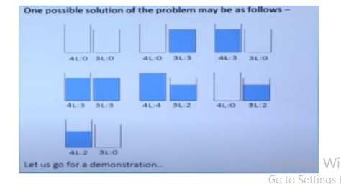

**CODE**:

def fill_4_gallon(x, y, x_max, y_max):

return (x_max, y)

def fill_3_gallon(x, y, x_max, y_max):

return (x, y_max)

def empty_4_gallon(x, y, x_max, y_max):

return (0, y)

def empty_3_gallon(x, y, x_max, y_max):

return (x, 0)

def pour_4_to_3(x, y, x_max, y_max):

transfer = min(x, y_max - y) # Max amount we can transfer from 4-gallon to 3-gallon jug

return (x - transfer, y + transfer)

def pour_3_to_4(x, y, x_max, y_max):

transfer = min(y, x_max - x) # Max amount we can transfer from 3-gallon to 4-gallon jug

return (x + transfer, y - transfer)

def dfs_water_jug(x_max, y_max, goal_x, visited=None, start=(0, 0)):

if visited is None:

visited = set() # Set to keep track of visited states

stack = [start] # Stack to store the states for DFS traversal

while stack:

state = stack.pop()

x, y = state

if state in visited:

continue

visited.add(state)

print(f"Visiting state: {state}")

if x == goal_x:

print(f"Goal reached: {state}")

return state

next_states = [

fill_4_gallon(x, y, x_max, y_max),

fill_3_gallon(x, y, x_max, y_max),

empty_4_gallon(x, y, x_max, y_max),

empty_3_gallon(x, y, x_max, y_max),

pour_4_to_3(x, y, x_max, y_max),

pour_3_to_4(x, y, x_max, y_max)

]

for new_state in next_states:

if new_state not in visited:

stack.append(new_state)

return None

x_max = 4

y_max = 3

goal_x = 2

dfs_water_jug(x_max, y_max, goal_x)

**OUTPUT**:  
